**Table of Contents Pages**

1. Applying CART to stock data (A1)...…………………………………………………3-12
2. Applying and explaining the Gini Index (A2)…………………………………….….12-16
3. Creation of the classification space(A3)...………………………………….….….….16-18
4. CART on five hundred random samples (B1)…………………………….…….……18-27
5. KNN on five hundred random samples (B1).…………………………...…………….27-28
6. NaiveBayes on five hundred random samples (B1).……………………………….…28-29
7. Logistic regression on five hundred random samples (B1).……………….……….…29-31
8. CART on five hundred recent samples (B2)……………………………………….…32-39
9. KNN on five hundred recent samples (B2).…………………….…………….………40-41
10. NaiveBayes on five hundred recent samples (B2).…………………………………….41-42
11. Logistic regression on five hundred recent samples (B2).………….……………….…42-45
12. Appendix – Lab example………………………………………………………………46-52
13. Appendix – Chapter Example………………………………………………………….52-61

A1. For this project we are going to use stock data from the company Alliance Energy with sticker “LNT” from date 01/01/2006 to 12/07/2021. We will be using classification and regression trees in R. Decision tree is a type of supervised learning algorithm that can be used in both regression and classification problems. It works for both categorical and continuous input and output variables. A root node is an entire population or sample and can be divided into further homogeneous sets. Splitting is a process for dividing a node into sub-nodes. The data for the LNT stock is then downloaded from Yahoo finance with the dates. The file was exported as an excel file that was named “LNT Final”. The columns which were outputted from Yahoo finance are: Date, Open, High, Low, Close, Adj Close, and Volume. It is important to note that we do need to make some changes to this data before it is inputted into R. Firstly, we find the returns of the data, to do this, we take the previous day’s close from current day’s close and the difference is then divided by the previous day’s close. We then name the column “Return” and then copy it and paste special as values. The next column, we want the “Range” of the stock price, as such we then subtract the day’s high from the day’s low for each day which would give us the range. Then we want to get the lag1 and lag2 of the “Return” column for the stock. The “Return” column is then copied and paste in the sheet twice in which one of the columns is then named “lag1” and the other “lag2”. For “lag1” data, we shift the cells down one place and for “lag2” data we shift the cells down two places. Then the rows without lag2 data is then deleted which then makes our new starting date 01/06/2006. Then we add a new column to the data called “LNTHiLo”. After that, we find the median of the return data which comes out to 0.077346%. For the high/low column we are basically quantifying the risk on that given day versus the median. As such, we input an if statement for that column in that if the return for that day is less than the median, we label that as high risk and if the return is equal to or more than the median, we say that the risk is low for that day. Then we create a new column called “LogRange” and we input the log of the “range” we computed earlier and then copy and paste special the values to remove the formulas. With that final action we have now completed the excel file needed for this project. After all of this editing, a snapshot of my excel csv file is as follows (all rows is not in the screenshot):

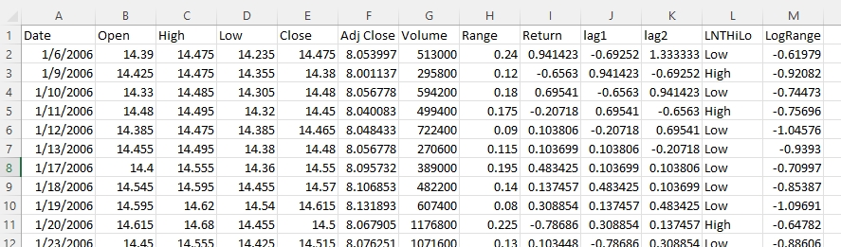

My aim is going to be to predict the stock range using classification and regression trees (CART). Firstly, I used to “getwd” function to see where my file would be pulled from and then dropped my excel file in that location:

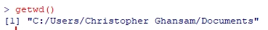

Then my LNT csv file was then loaded into R and read as follows:

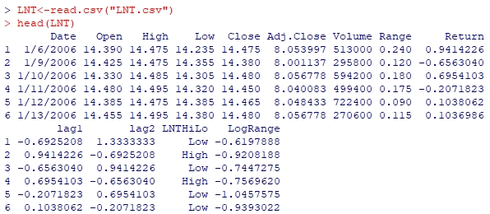

After that I called the libraries “tree” and “ISLR”:

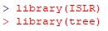

Next, I then reduced my sample size to two hundred random samples using the following function:



Then, I tried to verify how many rows exactly are in the data:

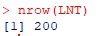

Then we set seed for ten as follows:



Next, I use half of the data as training data as follows:



The next step is to create the tree using the range data as primary and the close, open, high, and low as secondary data.



Then, I went and pulled the summary of the data screenshotted below:

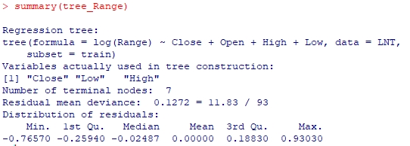

Then the “tree_Range” is plotted using the following functions:



The tree is as follows:

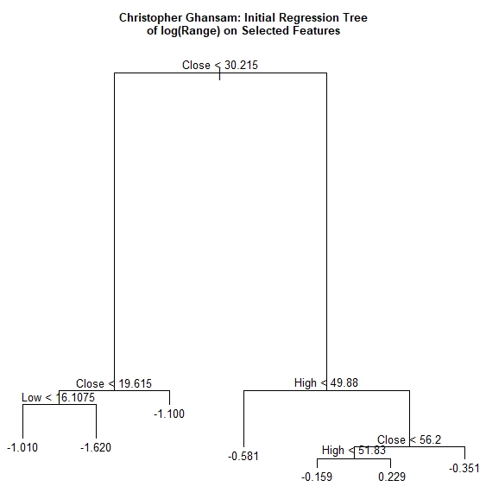

Then I tried it with “set.seed(20).



A six-fold cross-validation was done.



The CV range object is then structured as follows:

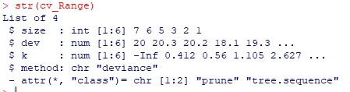

The cross-validation RSS for the test sample is then plotted as follows:



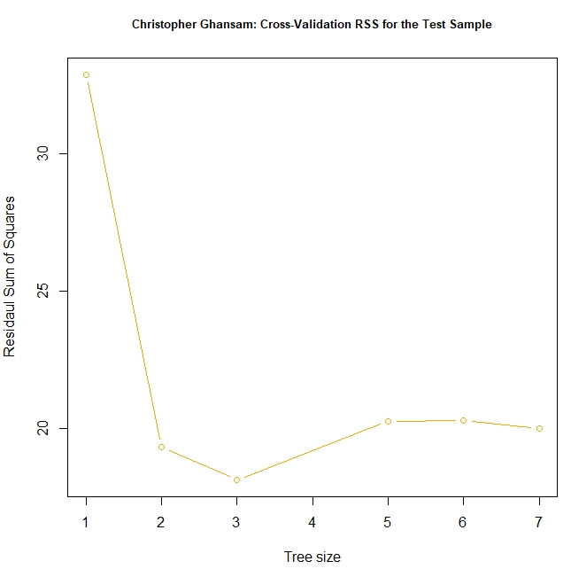

The point with the smallest RSS was identified and plotted on the cross-validation chart as follows:

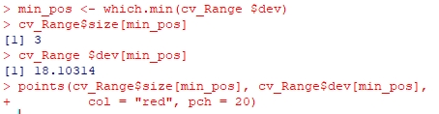

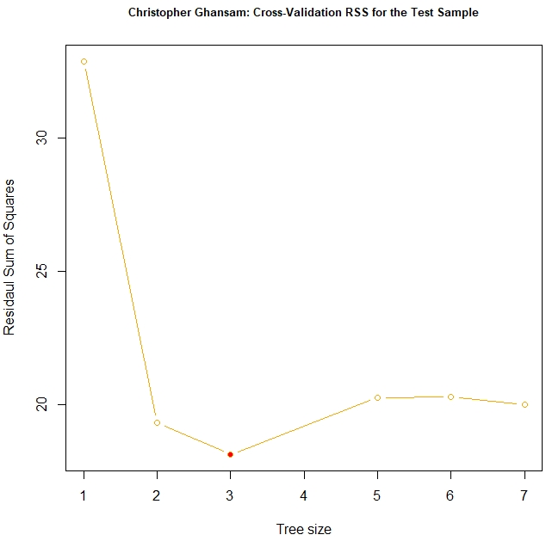

The sample was pruned to the full sample tree to the CV size with seven nodes or leaves.



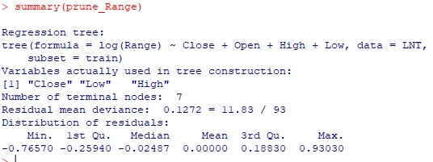

The pruned tree is then plotted as follows:



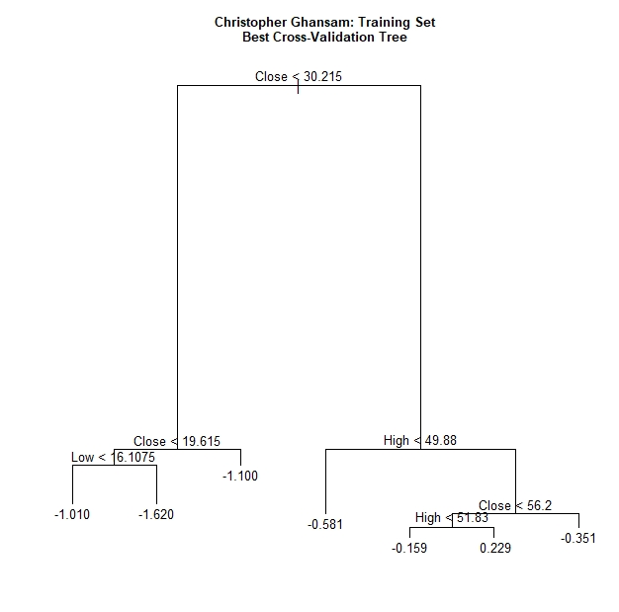

The SSR was trained for testing as follows:



If the tree size is one, there may be no explanatory variables and the prediction will be the mean of the dependent variable.

The data was then further trained and tested mean squared error as follows:

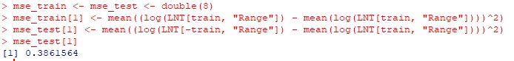

As you can we, I got 0.3861564 as the mean squared error. Next, I used a “for loop” to iterate over this data to further prune and fit it.

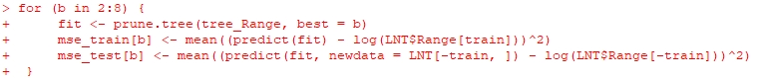

Then the MSE was plotted, as well as the MSE Train data and the MSE CV data to create standard error bands for the different tree sizes.

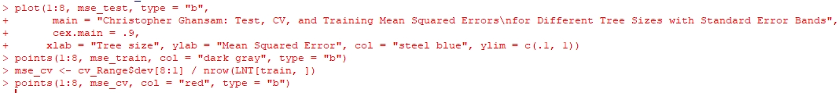

It is really amazing to see this coming together like this: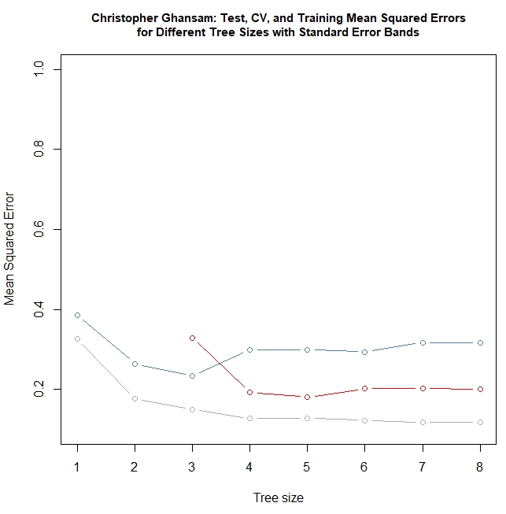

Another “for loop” was done to further train and validate the data and then draw the lines connecting the data points. A legend was then added to make the graph classier and more understandable to the user:

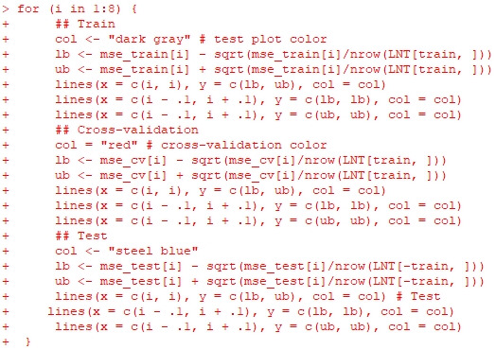



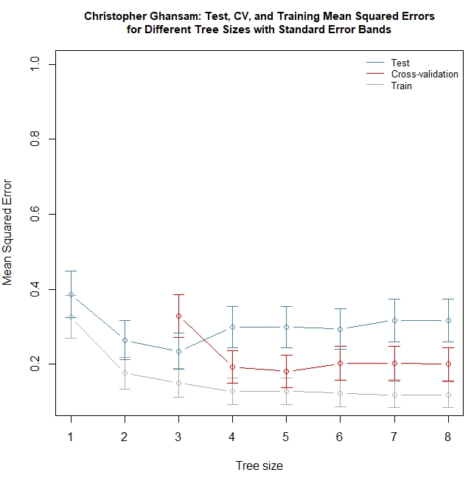

The package “leaps” was then used, because I am going to use it to compare which is the best fitted linear regression model using the training data. And then we train a subset of the range data as follows:



Then I input the following function, which will help me find the best model by criterion. After that, I input the regression formula matching the best CP alternative.

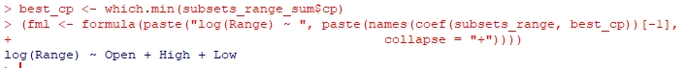

I further trained the data to get the best fit model. Here is the summary of the training data:

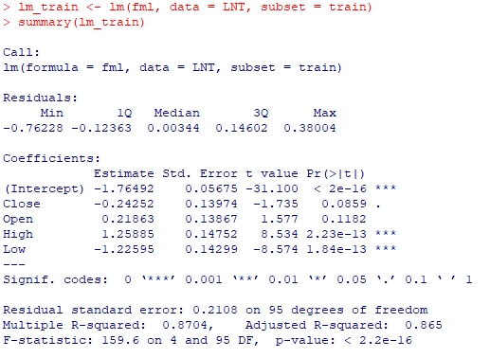

I then tested the predictions as follows:

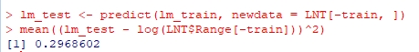

I further trained and tested the data in a bid to get more accurate predictions:

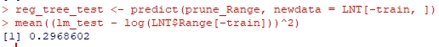

What we are seeing here is the two sets of regression trees that agree with each other.

In the summary data of these testing, we see the following:

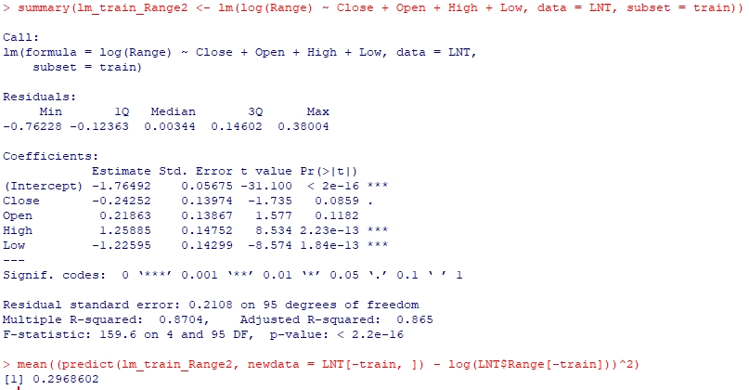

**A2.** Next, we are going to look at the Gini Index. According to the R Project, “The Gini coefficient is a measure of inequality among values of a distribution. The most used single measure for income inequality. The coefficient can theoretically range between 0 and 1, with 1 being the highest possible inequality (for instance: 1 person in a society has all income; the others none). But coefficients that are negative or greater than 1 are also possible because of negative values in the distribution. Compared to other measures of inequality, the Gini coefficient is especially sensitive for changes in the middle of the distribution.”

I think the Gini index is fascinating since it provides us with an analysis of the distribution of the population. I can see how this can be useful especially in econometrics. As such, now I am going to apply the Gini Index to the stock data.

Firstly, I installed and called the libraries rpart and rpart.plot.

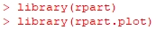

Then I created the Gini Tree model by using the same data I used for my CART.



After this, I called the Gini tree model, and the following is the result:

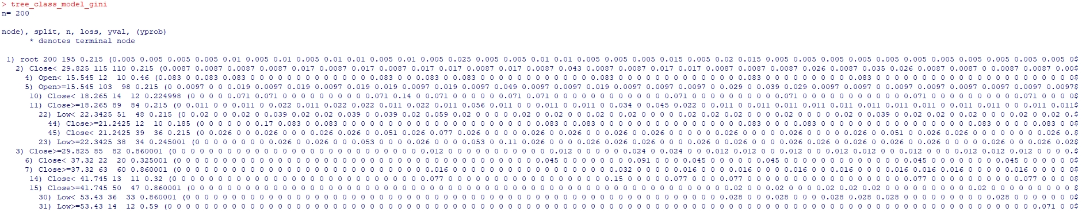

I then plot the Gini Tree using the following function:

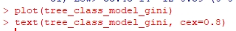

Below is the Gini tree.

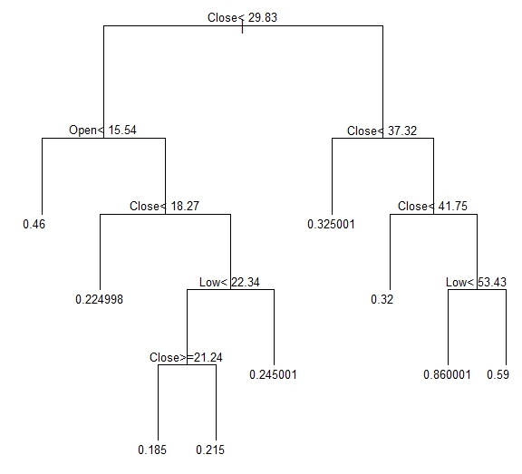

Then I plotted the Gini model with an extra three parameters and the following is the result.



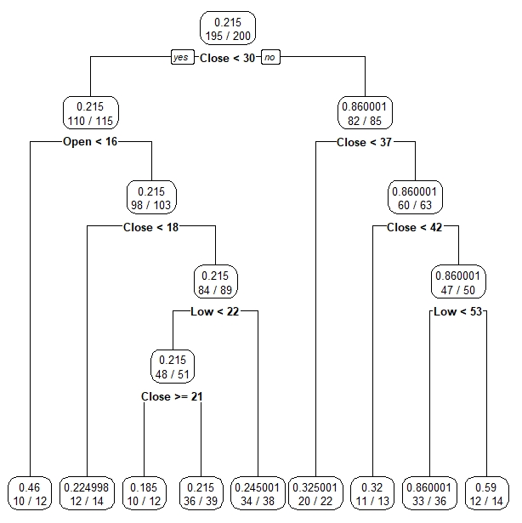

Then, I tried it with an extra one hundred and three.



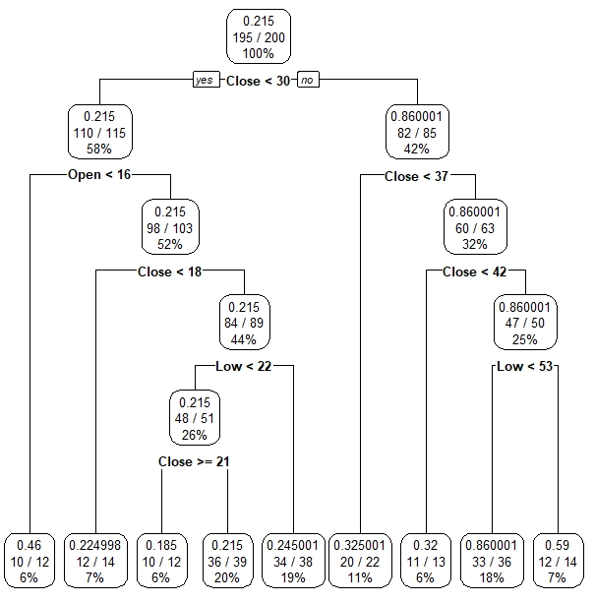

It did not change much which gives more validation to the model. Next, I am going to predict the range of the validation set and see how they matchup.



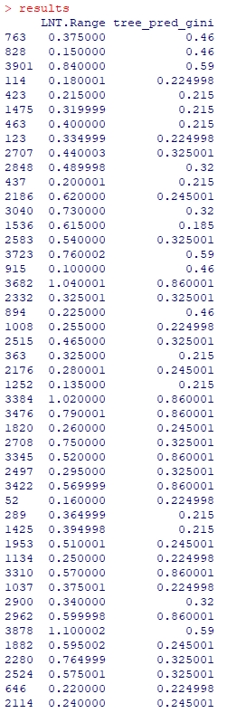

These are just some of the results from the Gini index and looking at them comparatively it is not significant as some of the predictions are more than 100% off the actual data.

**A3.** Next, I am going to create a classification space for this data. A classification space basically shows us the distribution of the data. We are going to run a function called “NewProbeKnnBig” on LNT stock range data. I will use the lag1 and lag2 data in columns 10:11. The function is as follows:

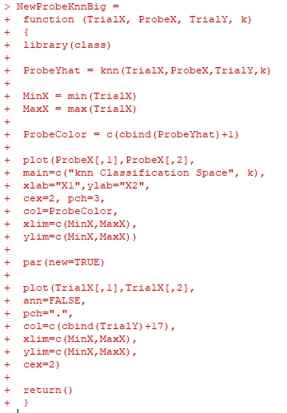

As you can see it contains test and trial data which we will now construct functions to contain. We are now going to train columns ten and eleven.







Then, I called back the “NewProbeKnnBig” function to create the classification space. Which came out so beautiful as we can see below.



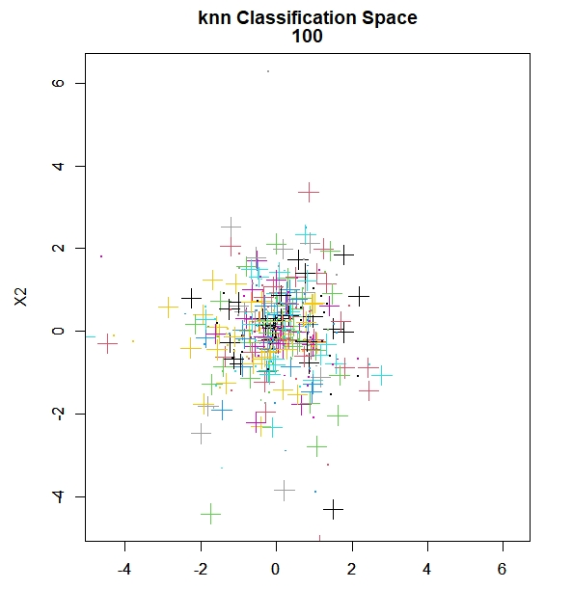

As can be observed, there are only a few outliers, otherwise it’s mostly nested around zero.

Now, let’s see how the classification space looks when we up the number from one hundred to two hundred.



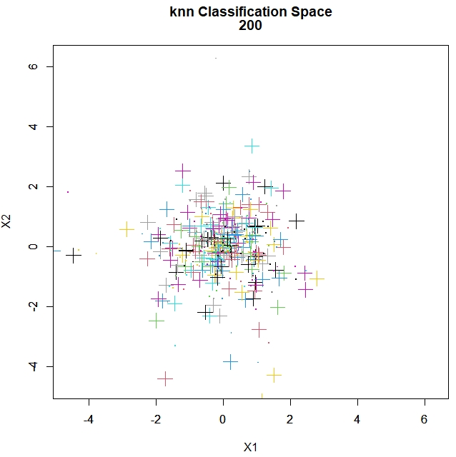

It looks almost identical, which then goes to show, statistically, my sample seems to be a good representation of the population.

**B1**. Next, I am going to experiment with five hundred (500) random samples of my data using CART, KNN, naïve Bayes and logistic regression. First, I will start off with the CART model.

Firstly, I used to “getwd” function to see where my file would be pulled from and then dropped my excel file in that location:



Then my LNT csv file was then loaded into R and read as follows:



After that I called the libraries “tree” and “ISLR”:



Next, I then reduced my sample size to five hundred (500) random samples using the following function:



Then, I tried to verify how many rows exactly are in the data:

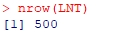

Then I set seed for ten as follows:



Next, I use half of the data as training data as follows:



The next step is to create the tree using the range data as primary and the close, open, high, and low as secondary data.



Then, I went and pulled the summary of the data screenshotted below:

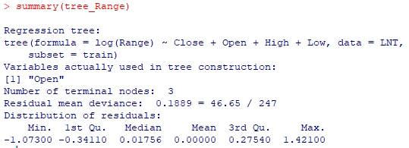

Then the “tree_Range” is plotted using the following functions:



The tree is as follows:

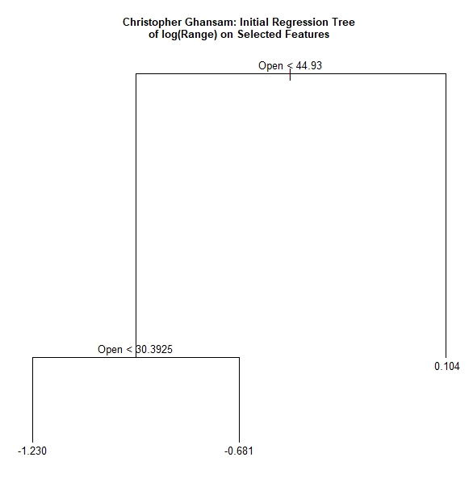

Then I tried it with “set.seed(20).



A six-fold cross-validation was done.



The CV range object is then structured as follows:

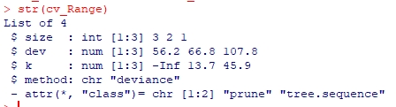

The cross-validation RSS for the test sample is then plotted as follows:



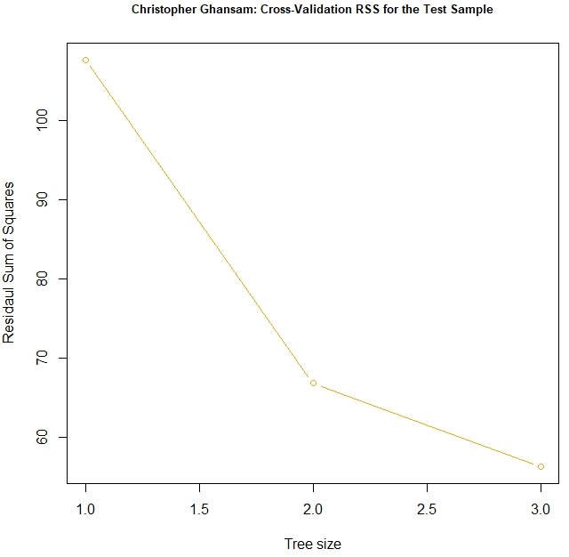

The point with the smallest RSS was identified and plotted on the cross-validation chart as follows:

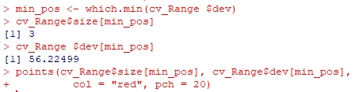

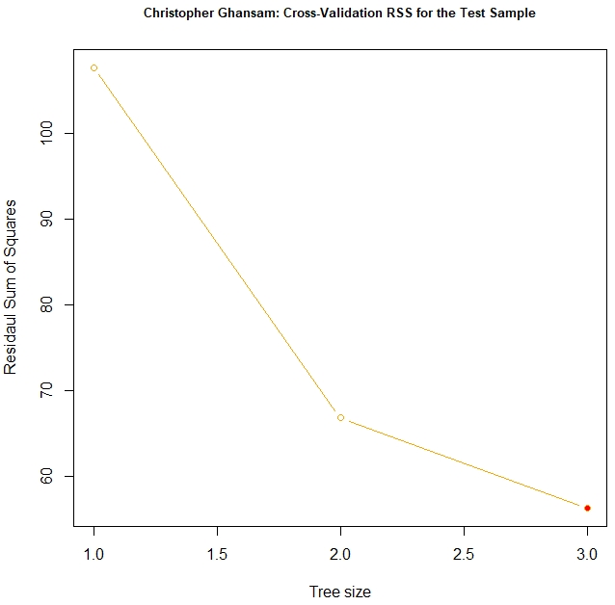

The sample was pruned to the full sample tree to the CV size with seven nodes or leaves.



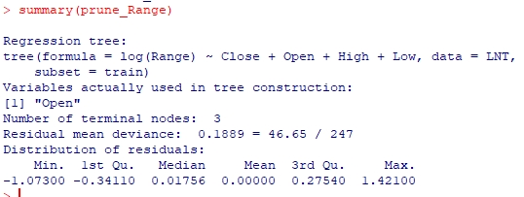

The pruned tree is then plotted as follows:



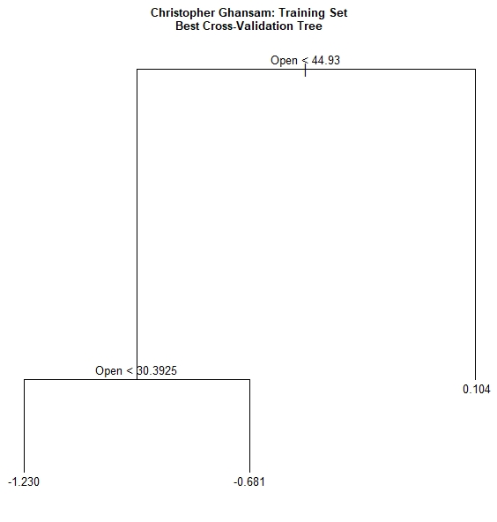

The SSR was trained for testing as follows:



If the tree size is one, there may be no explanatory variables and the prediction will be the mean of the dependent variable.

The data was then further trained and tested mean squared error as follows:

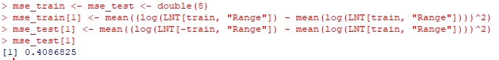

As you can we, I got 0.4086825 as the mean squared error. Next, I used a “for loop” to iterate over this data to further prune and fit it.

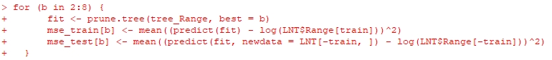

Then the MSE was plotted, as well as the MSE Train data and the MSE CV data to create standard error bands for the different tree sizes.

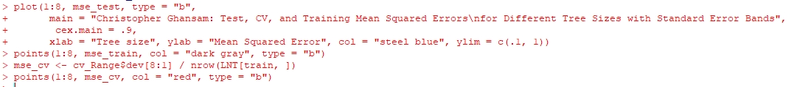

It is really amazing to see this coming together like this:

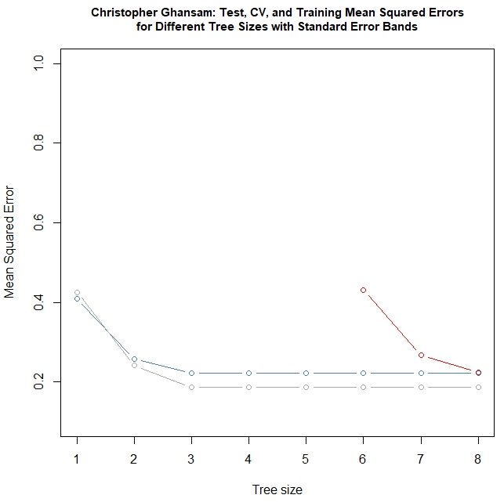

Another “for loop” was done to further train and validate the data and then draw the lines connecting the data points. A legend was then added to make the graph classier and more understandable to the user:

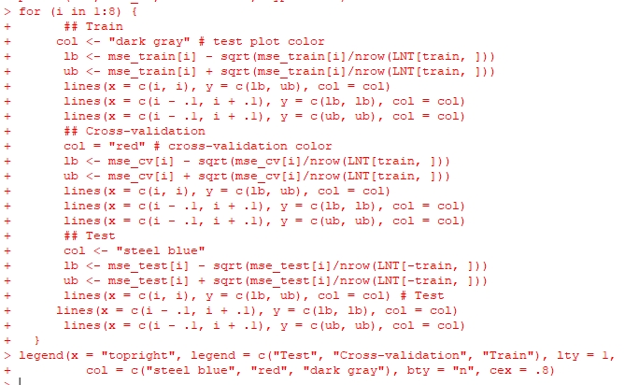

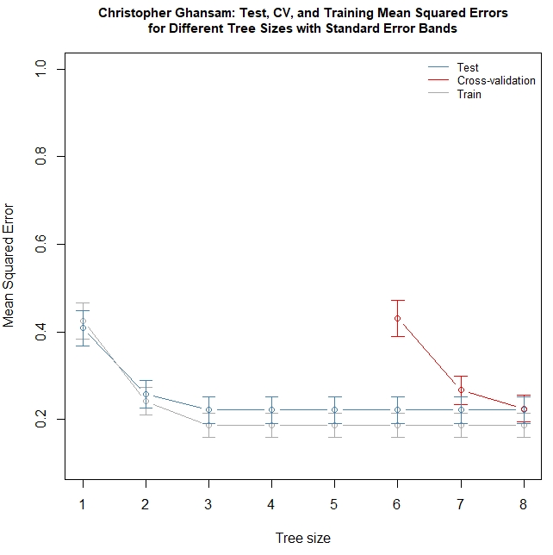

The package “leaps” was then used, because I am going to use it to compare which is the best fitted linear regression model using the training data. And then we train a subset of the range data as follows:



Then I input the following function, which will help me find the best model by criterion. After that, I input the regression formula matching the best CP alternative.

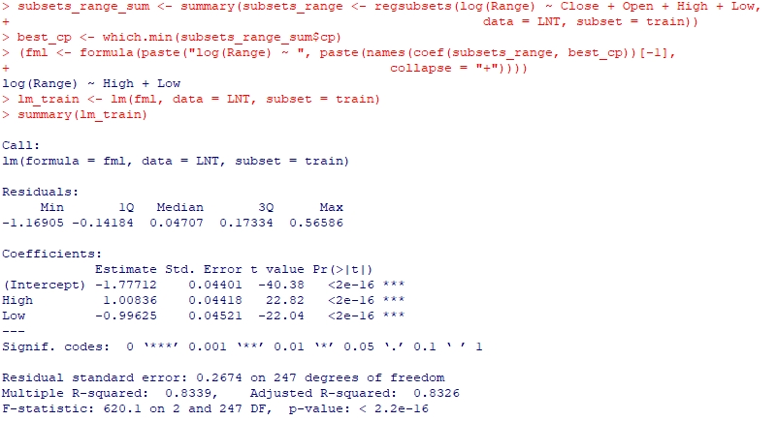

I then tested the predictions as follows:

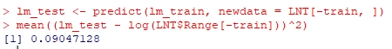

I further trained and tested the data in a bid to get more accurate predictions:



What we are seeing here is the two sets of regression trees that agree with each other.

In the summary data of these testing, we see the following:

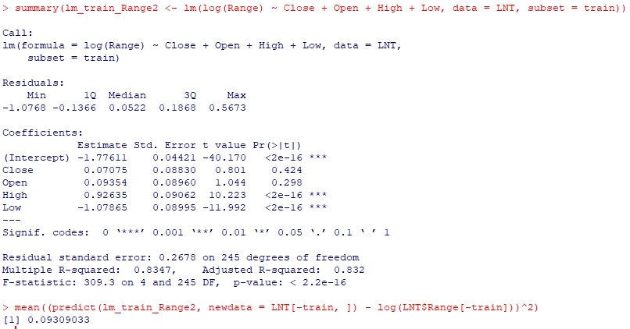

Next, I will go over the knn function with this same data set. Firstly, I load the library function.



Then, I will enter the probe knn function as follows:

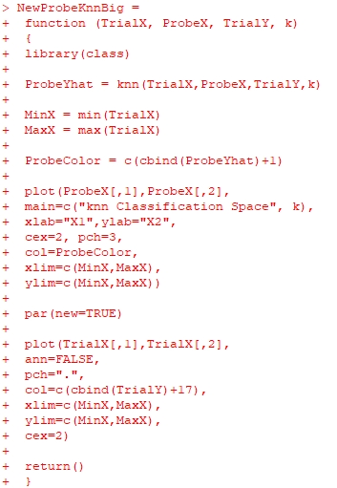

Then, the training data is inputted as follows:

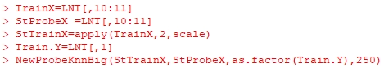

The classification space is as follows:

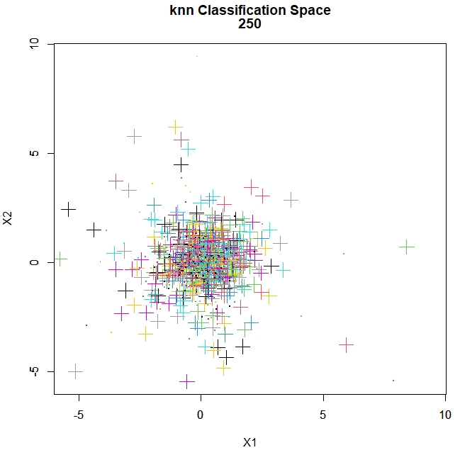

The NaiveBayes function was used as follows.

I first called the library e(1071) and caTools was called.

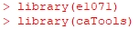

Then I set seed as ten (10).



Then, I divided the data into sample and test data, then train, and check the number of rows in each data set.

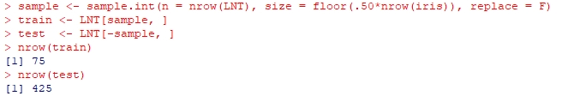

After this, I went ahead with the predictions, which is as follows. This seems like a gold mine for day traders, because knowing the statistical probability of the range bound is valuable information.

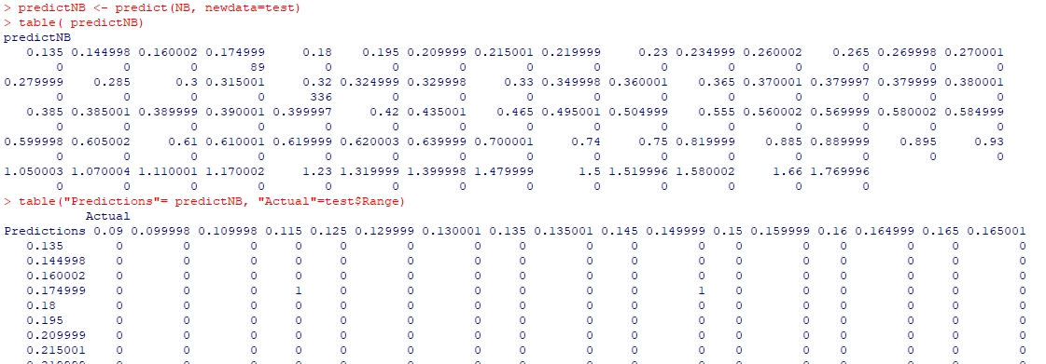

Next, we will look at the log regression for this dataset on a sample of five hundred rows as well. A new column was added called “HiLo”. In this column, if a day is determined to be low risk, it carries a value of zero (0), if its high risk, it carries a value of one (1).

First the glm2 package is loaded.



The half of the data was pulled as samples:



Then the glm model was made as follows.



Below is a summary of the glm model.

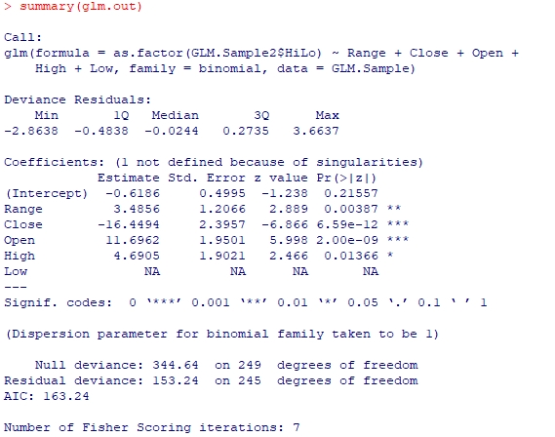

Then I began plotting the data as follows:

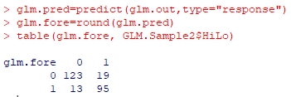

The range was plotted first.



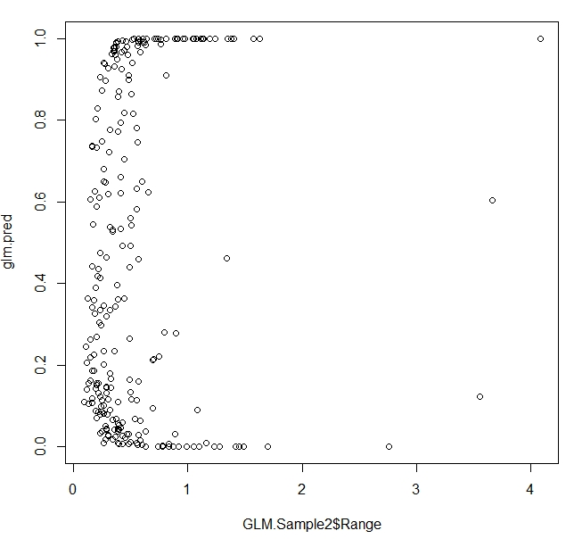

The close linear regression is as follows:



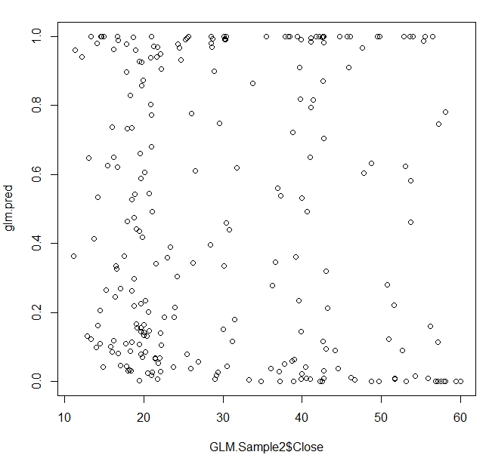

I think the plot of the Range is the most interesting because we can see how the low risk items show a good positive return and the high risk ones show negative return on average.



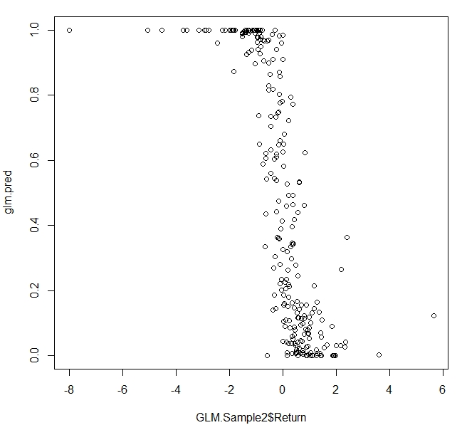

**B2**. In comparison of the methods used, I think each has its own distinct example and it depends on how you want to view the data and the specific style of risk assessment you want to do. Next, I am going to use the most recent five hundred (500) days and reassess the risk.

Then my LNT csv file was then loaded into R and read as follows:

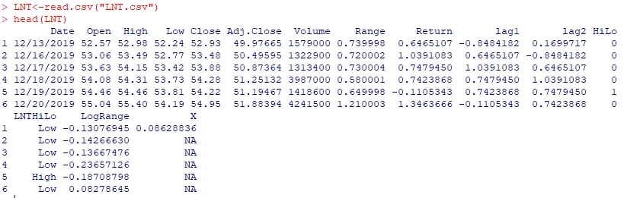

I tried to verify how many rows exactly are in the data:

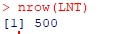

Then I set seed for ten as follows:



Next, I use half of the data as training data as follows:



The next step is to create the tree using the range data as primary and the close, open, high, and low as secondary data.



Then, I went and pulled the summary of the data screenshotted below:

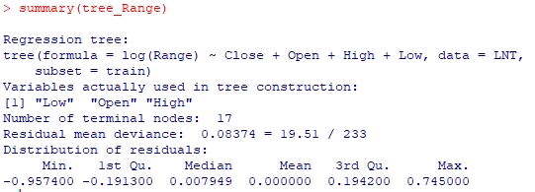

Then the “tree_Range” is plotted using the following functions:



The tree is as follows:

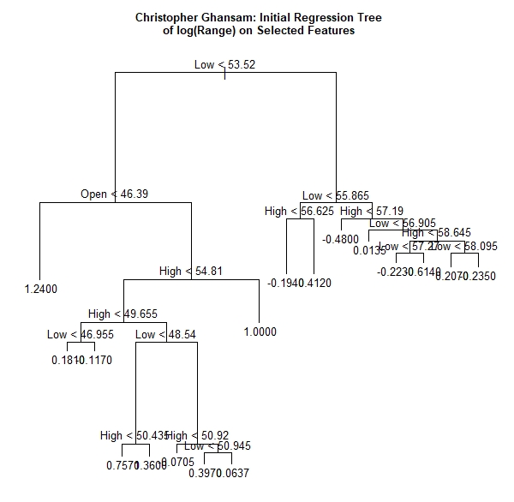

Then I tried it with “set.seed(20).



A six-fold cross-validation was done.



The CV range object is then structured as follows:

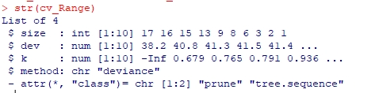

The cross-validation RSS for the test sample is then plotted as follows:



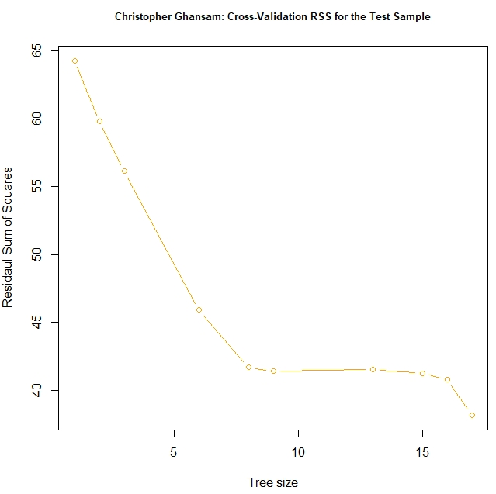

The point with the smallest RSS was identified and plotted on the cross-validation chart as follows:

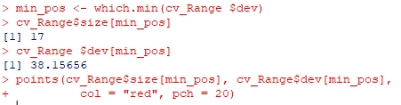

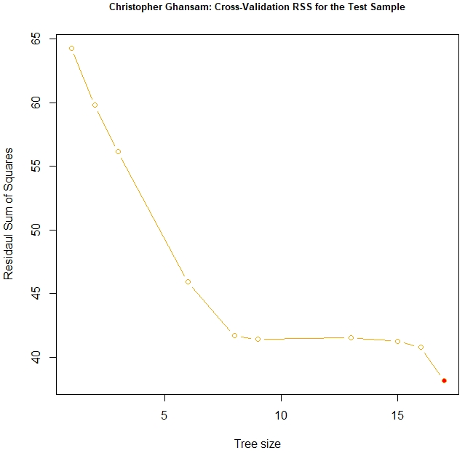

The sample was pruned to the full sample tree to the CV size with seven nodes or leaves.

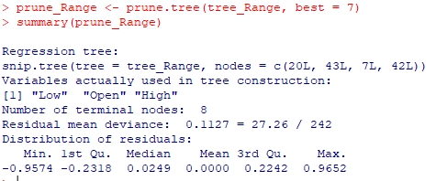

The pruned tree is then plotted as follows:



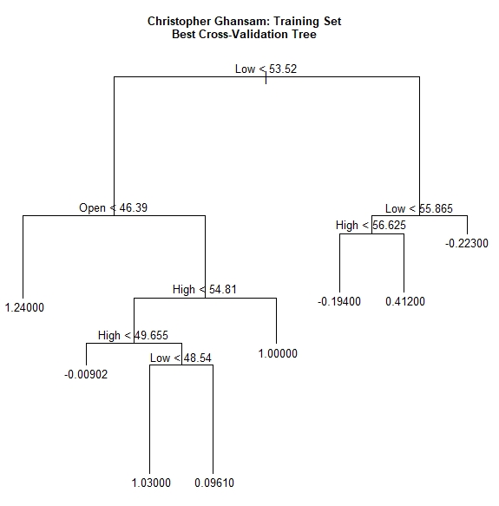

The SSR was trained for testing as follows:



If the tree size is one, there may be no explanatory variables and the prediction will be the mean of the dependent variable.

The data was then further trained and tested mean squared error as follows:



As you can we, I got 0.2701714 as the mean squared error. Next, I used a “for loop” to iterate over this data to further prune and fit it.



Then the MSE was plotted, as well as the MSE Train data and the MSE CV data to create standard error bands for the different tree sizes.



It is really amazing to see this coming together like this:

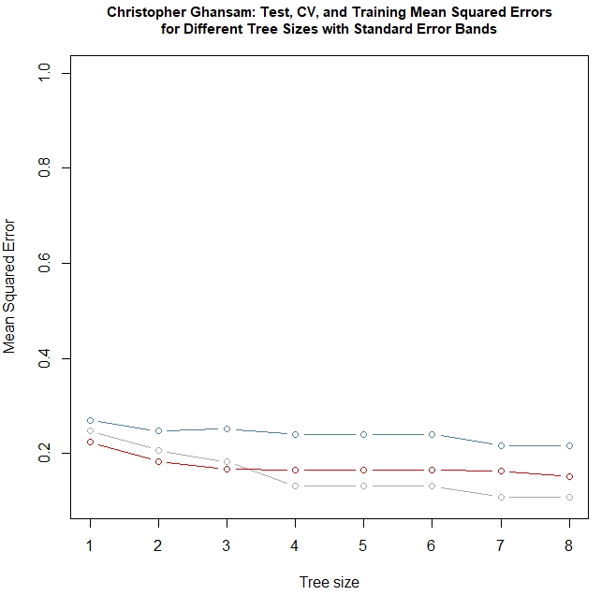

Another “for loop” was done to further train and validate the data and then draw the lines connecting the data points. A legend was then added to make the graph classier and more understandable to the user:

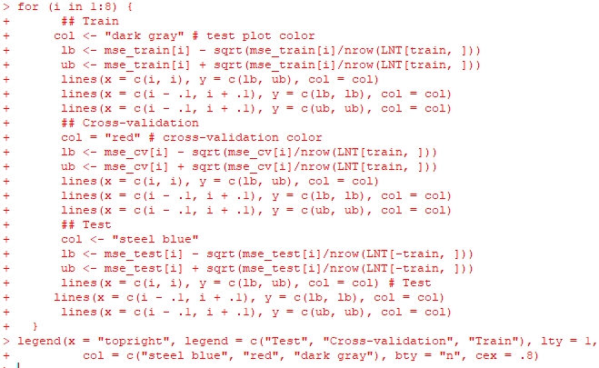

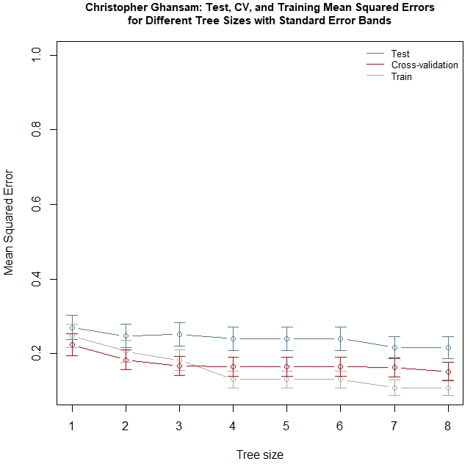

The package “leaps” was then used, because I am going to use it to compare which is the best fitted linear regression model using the training data. And then we train a subset of the range data as follows:



Then I input the following function, which will help me find the best model by criterion. After that, I input the regression formula matching the best CP alternative.

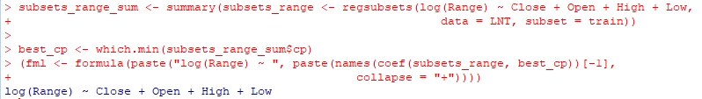

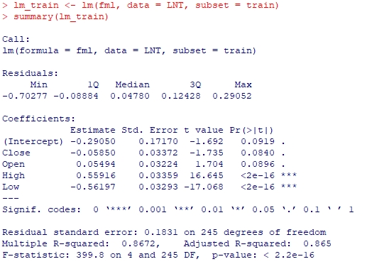

I then tested the predictions as follows:



I further trained and tested the data in a bid to get more accurate predictions:

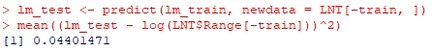

What we are seeing here is the two sets of regression trees that agree with each other.

In the summary data of these testing, we see the following:

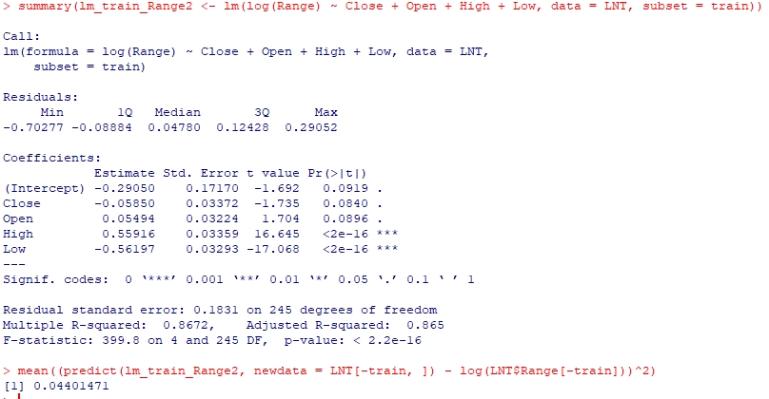

Next, I will go over the knn function with this same data set. Firstly, I load the library function.



Then, I will enter the probe knn function as follows:

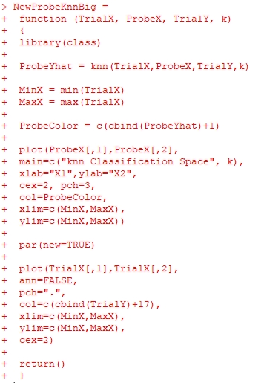

Then, the training data is inputted as follows:

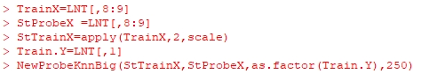

We are looking at the return in coordination with the range of the stock data. The classification space is as follows:

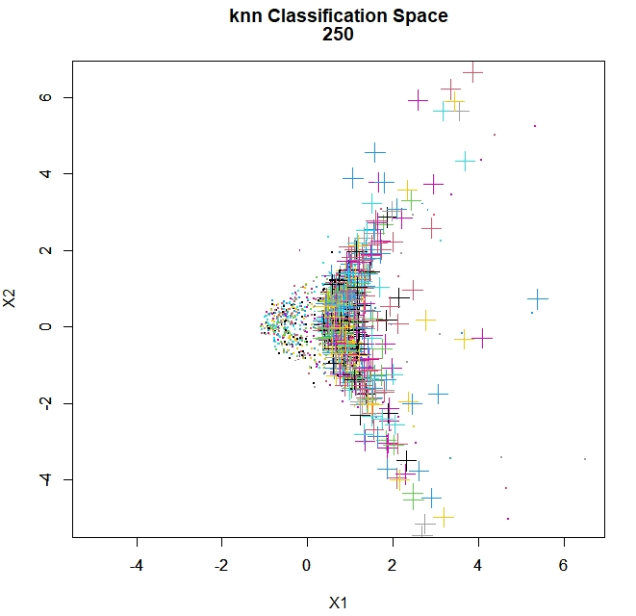

The NaiveBayes function was used as follows.

I first called the library e(1071) and caTools was called.

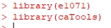

Then I set seed as ten (10).



Then, I divided the data into sample and test data, then train, and check the number of rows in each data set.

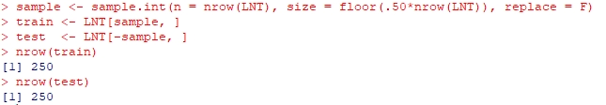

After this, I went ahead with the predictions, which is as follows. This seems like a gold mine for day traders, because knowing the statistical probability of the range bound is valuable information.



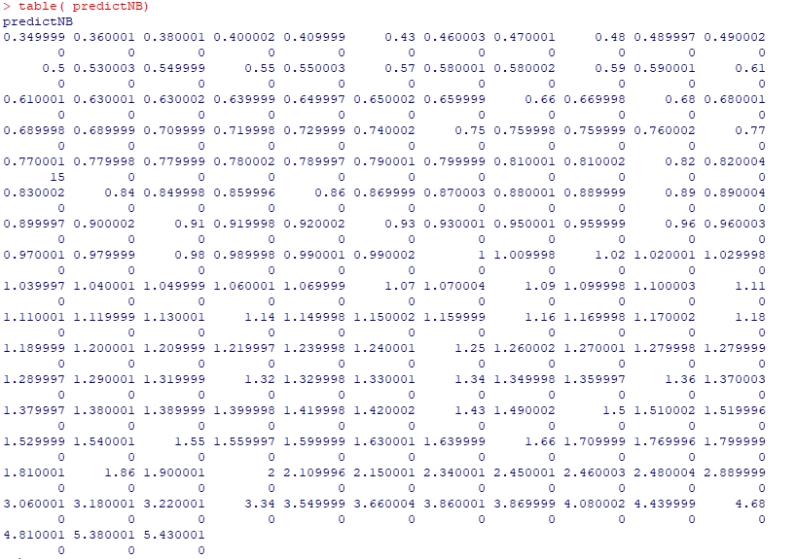

Next, we will look at the log regression for this dataset on a sample of five hundred rows as well. A new column was added called “HiLo”. In this column, if a day is determined to be low risk, it carries a value of zero (0), if its high risk, it carries a value of one (1).

First the glm2 package is loaded.



Then half of the data was pulled as samples:



Then the glm model was made as follows.



Below is a summary of the glm model.

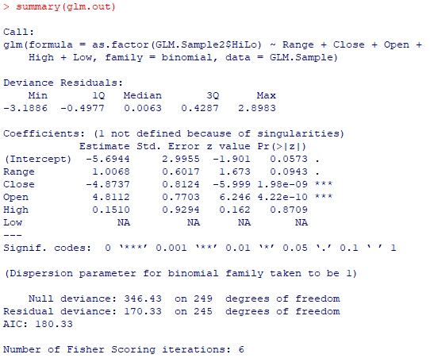

Then I began plotting the data as follows:

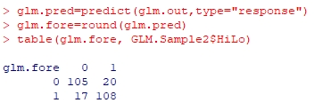

The range was plotted first.



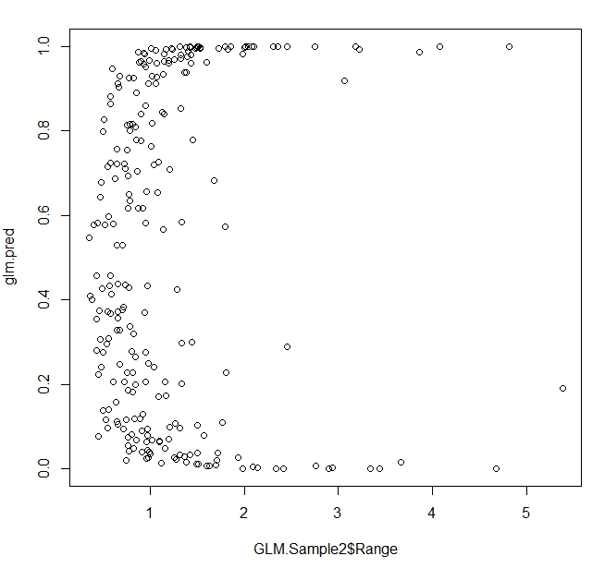

The close linear regression is as follows:



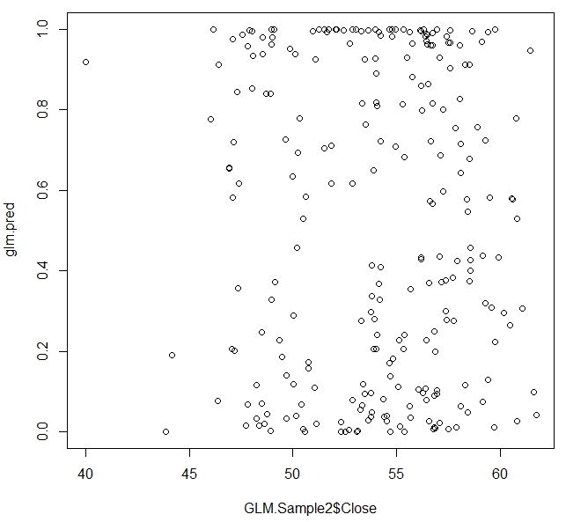

I think the plot of the return is the most interesting because we can see how the low-risk items show a good positive return and the high-risk ones show negative return on average.



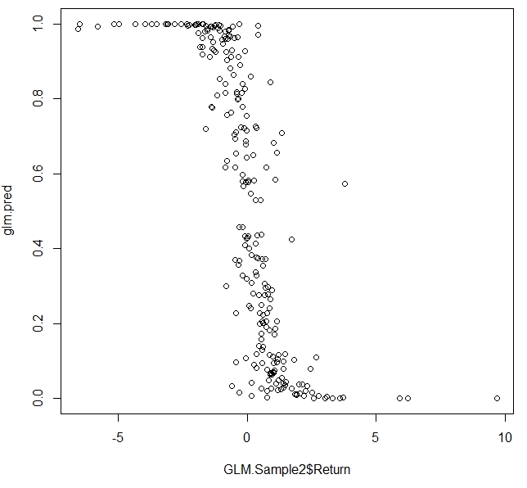

**Appendix**

**Lab Example**

The carseats data along with all necessary libraries was loaded into R as follows:

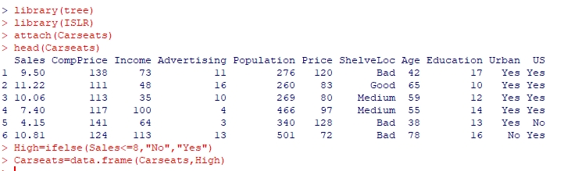

Next, I am going to build a basic tree. Here is the summary of the plot data:

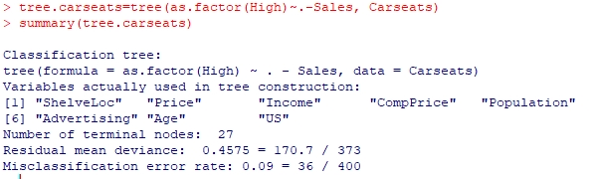

Here is now the plot:

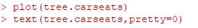

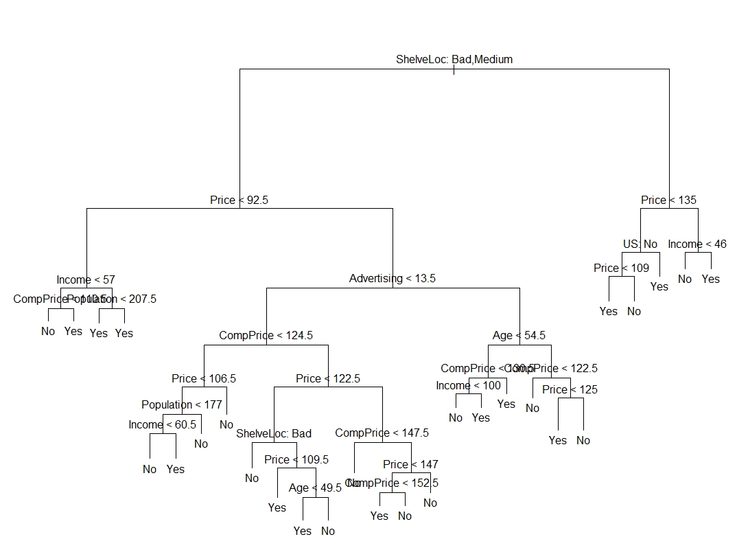

Below are the details of the tree:

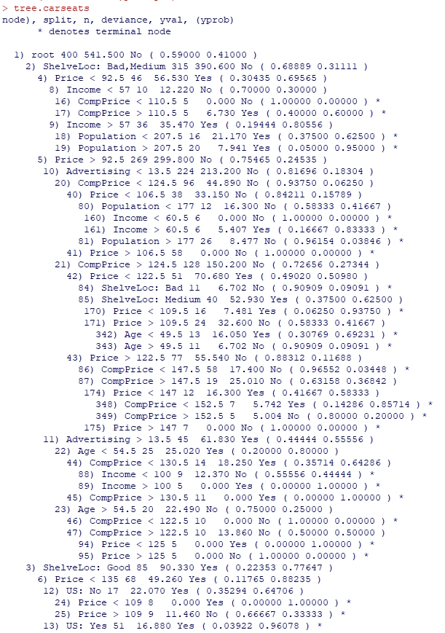

Then I went on to evaluate the validation set with the following:

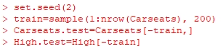

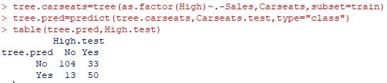

Next, I am going to try to see if pruning improves the results versus validation testing. I am going to search for the tree size with the best fit validation. We get the following results:

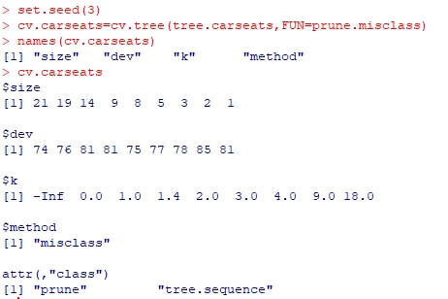

Now I am going to plot the misclasses and the difficulty. See code and plot as follows:



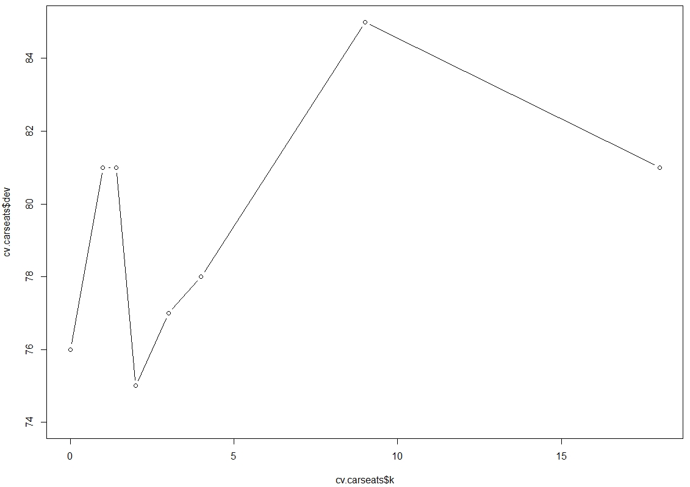

Now, I am going to prune the tree to nine leaves and run the prediction table.

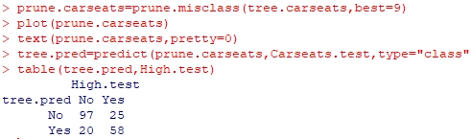

The following is the pruned tree:

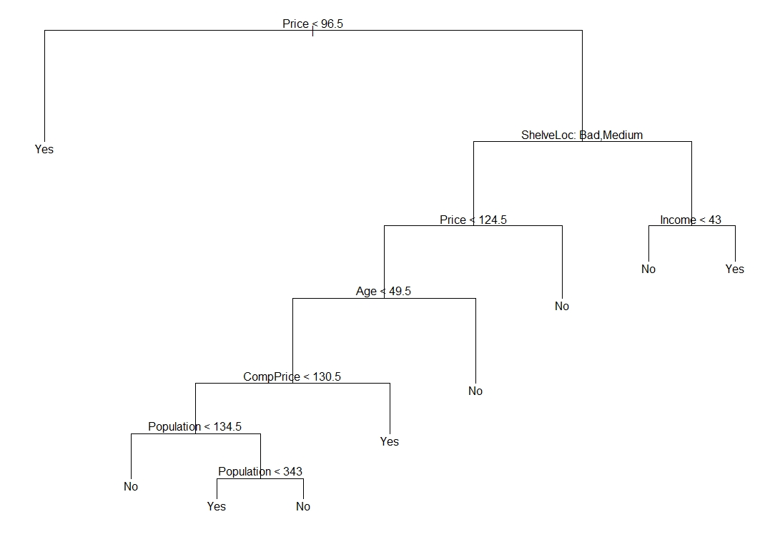

As we can see the pruned tree provided more accurate results that are easier to interpret. Now I am going to see if we increase the size of the tree what will happen.

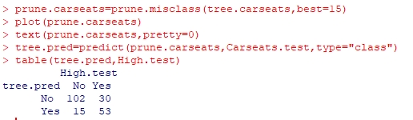

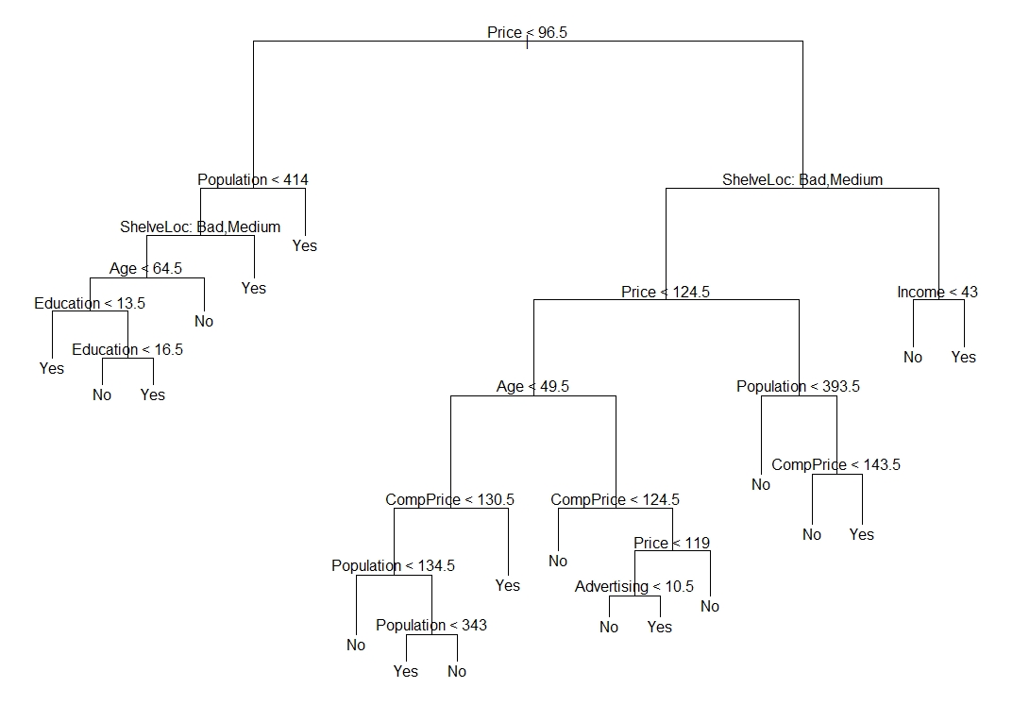

As we can see, by increasing the tree size, accuracy was reduced.

**Chapter Example**

The following is the chapter example for chapter 8 – classification and regression trees.

Firstly, the packages “ISLR” and “tree” was installed in R using the CRAN mirror. Then, these packages were loaded in R as follows:

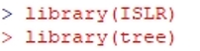

Then I removed any missing values from the hitter’s data as follows:

After that, I used the function “set.seed” for replication:



Then, I wanted to see how many data points exactly is in the data set, which is as follows:



About half of the sample data was used for training the algo as follows:



The tree is then built out with the column data from the original set which omits the missing values and then we extract the summary points as follows:

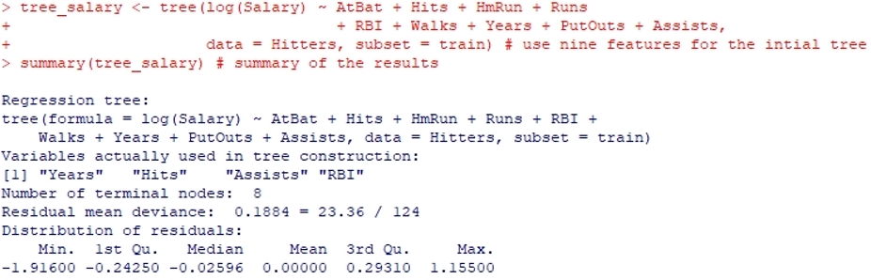

As we can see from the above, the statistical summary of the data is shown. Next, I went ahead to plot the summary data as follows:



It was incredible to see this being put together after hours of trying to get it done, and then the graph was as follows:

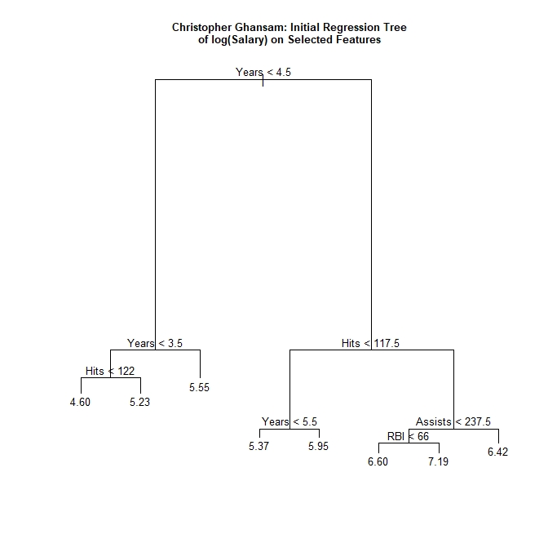

I need to select the best tree size using cross validation. As such, I experimented with different levels of replication to ensure quality. So, the “set.seed” function was used again as follows:



A six-fold cross-validation was done, because it divides 132 exactly which is the training set we used.



The CV salary object is then structured as follows:

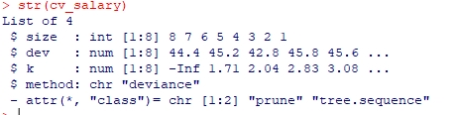

The cross-validation RSS for the test sample is then plotted as follows:



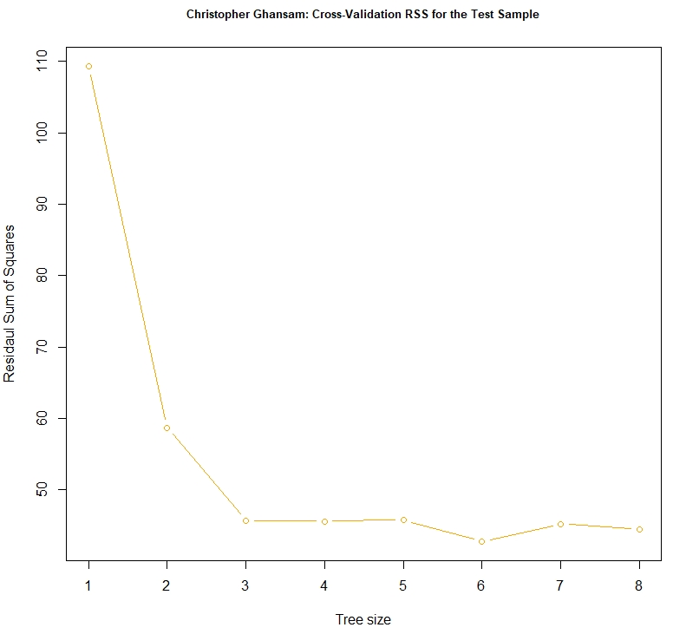

The point with the smallest RSS was identified and plotted on the cross-validation chart as follows:

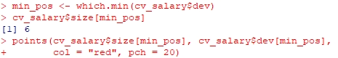

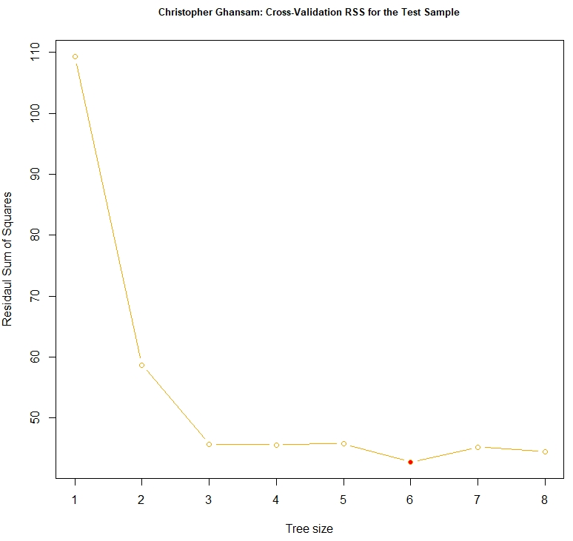

The sample was pruned to the full sample tree to the CV size with seven nodes or leaves.

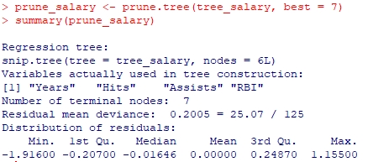

The pruned tree is then plotted as follows:



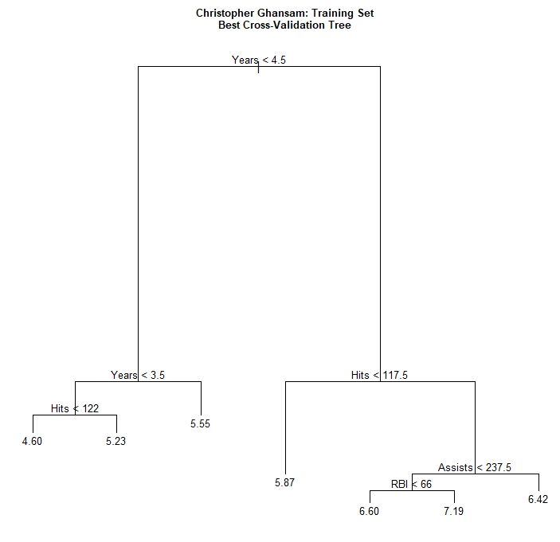

The SSR was trained for testing as follows:



If the tree size is one, there may be no explanatory variables and the prediction will be the mean of the dependent variable.

The data was then further trained and tested as follows:



As you can we, I got 0.7817446 from my test data. Next, I used a “for loop” to iterate over this data to further prune and fit it.



Then the MSE was plotted, as well as the MSE Train data and the MSE CV data to create standard error bands for the different tree sizes.

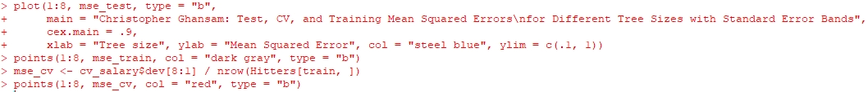

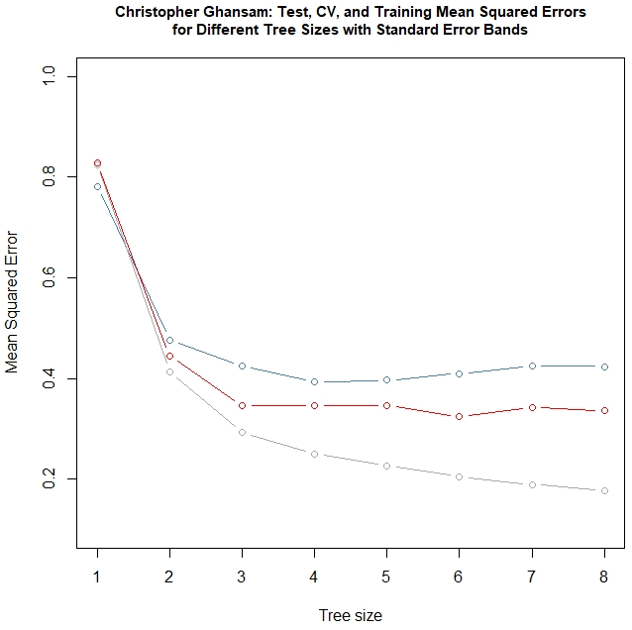

Another “for loop” was done to further train and validate the data and then draw the lines connecting the data points.

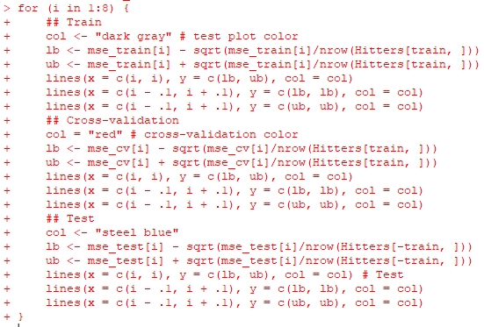

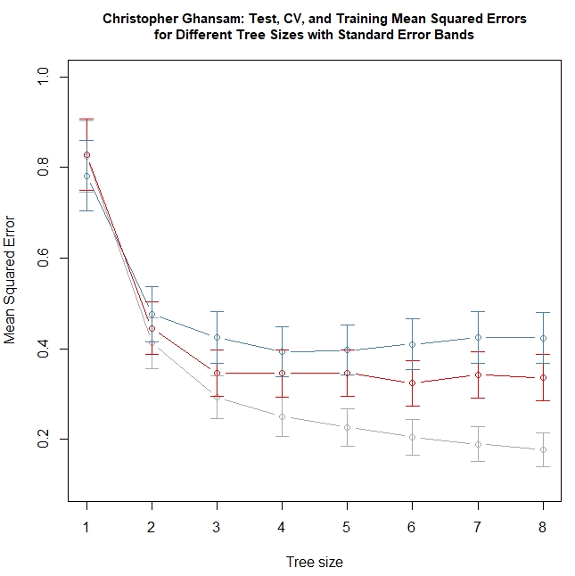

A legend was then added to make the graph classier and more understandable to the user:



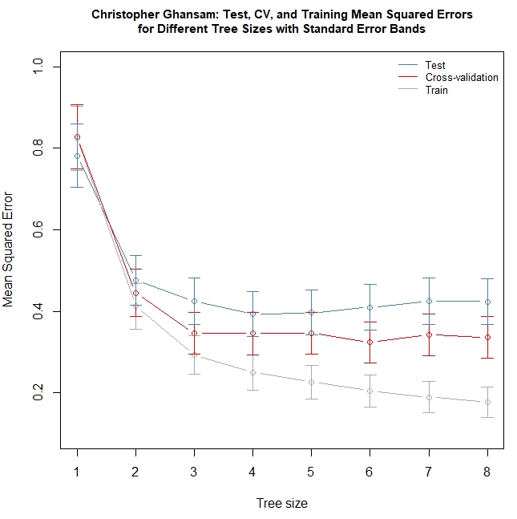

The package “leaps” was then installed, because I am going to use it to compare which is the best fitted linear regression model using the training data. And then we train a subset of the salary data as follows:

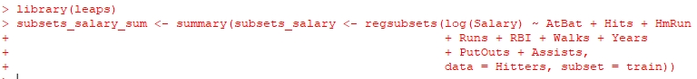

Then I input the following function, which will help me find the best model by criterion:



After that, I input the regression formula matching the best CP alternative.



I further trained the data to get the best fit model:



Here is the summary of the training data:

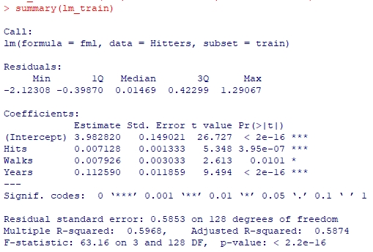

I then tested the predictions as follows:

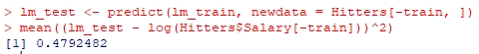

I further trained and tested the data in a bid to get more accurate predictions:



In the summary data of these testing, we see that assists data is not significant in predicting the hitter’s salary, which is quite a phenomenal finding since one would instinctively assume as such.

